9.2D

COS10009

Introduction to programming

**Thanh Minh**

**Student ID: 103809048**

Flow Explanation document

Swinburne University of Technology

I will write up a lot of code so for people who will view my code for the custom program, they can understand quickly and will know the flow of my program. Furthermore, when I work in a company, I also need to comment to explain the code so that if anyone going to fix the code, they will know exactly where to fix otherwise they have to work the program all over again because they don’t understand the code.

1. Starting page game

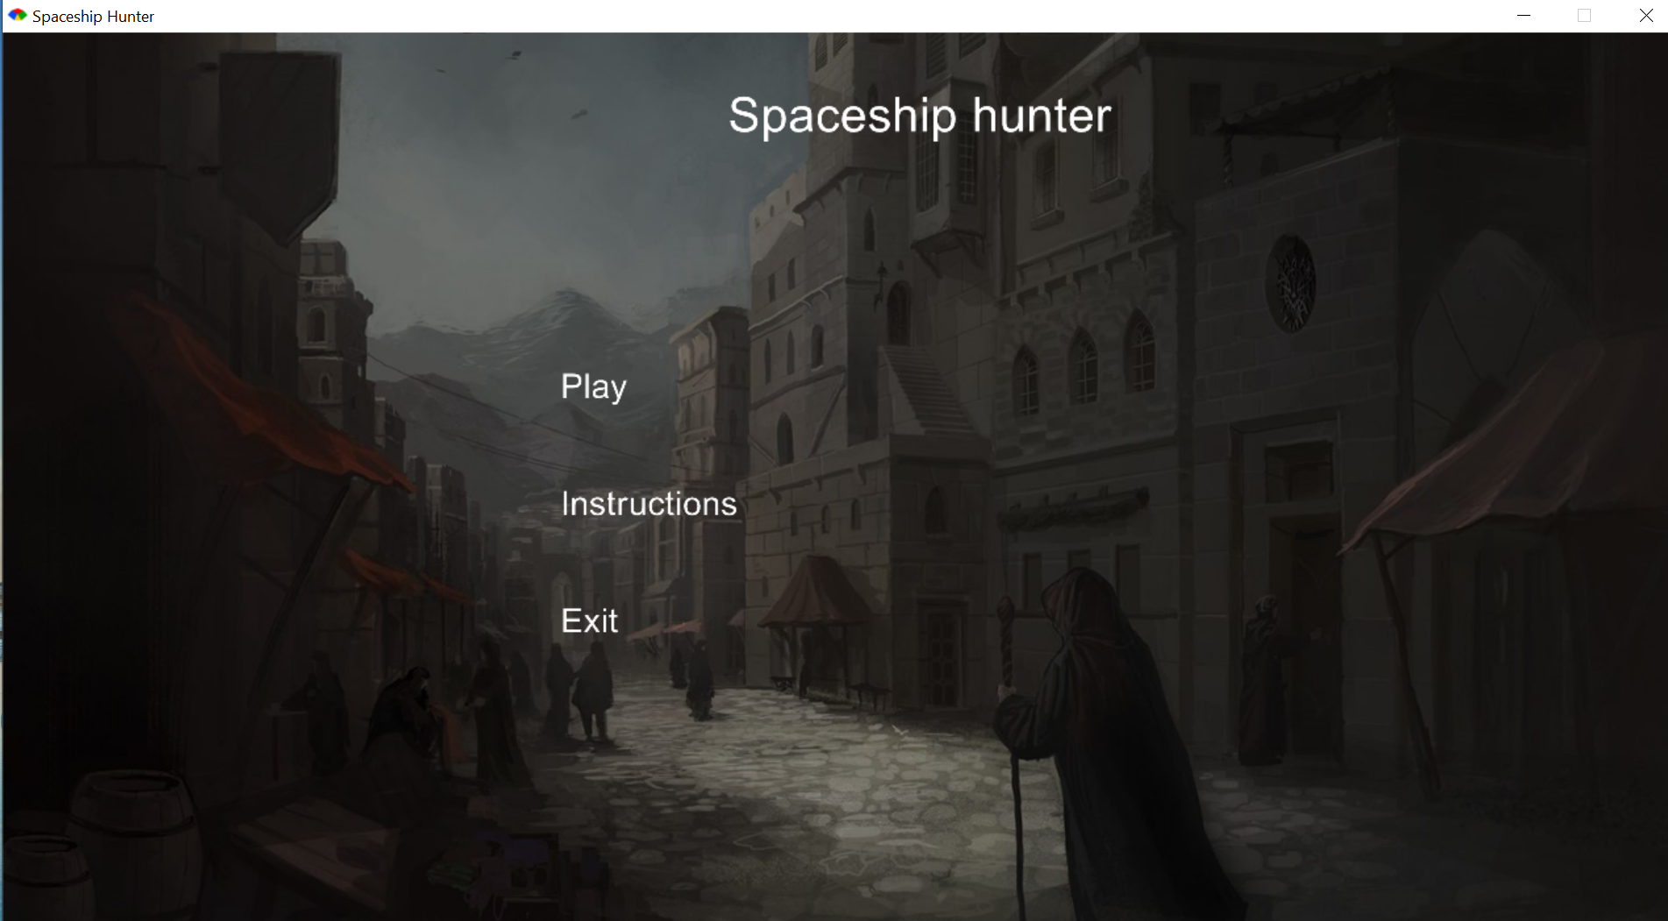

Figure 1: the entry page

This is the entry page of my game and there will be 3 options to choose. The user can both use the mouse or the keyboard up and down in order to move to the choice they want. When the current option is Play, and the user press the keyboard up, the error sound will play or when the current option is Exit, if the user press the keyboard down, the program will also play the error sound.

For the first option, the user will be directed to the choosing ship page.

For the second option, the user will be directed to the choosing ship page.

For the third option, the program will be closed immediately

1. Instructions page

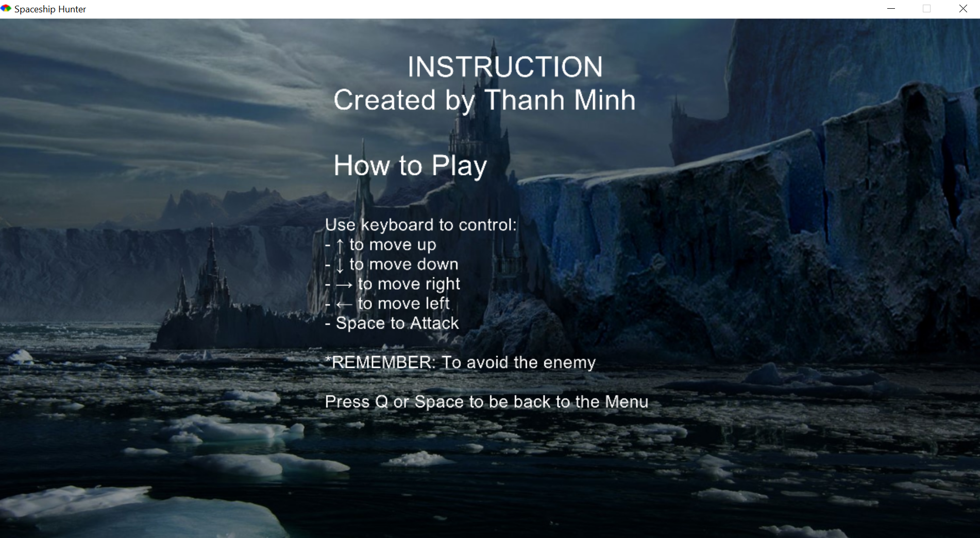

Figure 2: Instruction page

For this page, the user will know how to play and interact with the ship by using keyboard

1. Selecting page

Figure 3: Selecting Player page

4.Playing and Ending page

I’m working on it so I will explain in another file later.